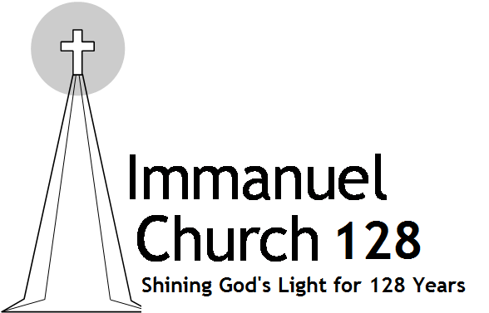
Immanuel Church Newsletter October 2020

A Look Back, Forward & Around
A View from the Pew
by Joyce Halvorsen

Immanuel Church will begin its 129th year of worship October 23rd. No one can argue this is quite an accomplishment! As you look at the banner at the front of the church marking the 100th Anniversary, do you ever wonder what would the 13 founding members think if they visited Immanuel today?

• Would they find us faithful in believing the Bible is the Word of God and it is a reference to live by?
• Would they find us faithful in showing God’s love to one another and the community?
• Would they find us faithful in worshipping together?

In 1891 when Immanuel was founded, Lincoln was just over 20 years old. There were more telegraph stations than telephone companies and the state capitol building we know today was yet to be constructed. In addition, Lincoln was becoming a railroad center with eight different railroads servicing the area and many employees coming from the North and South Bottoms.

The founders were strong, Bible-believing German men and women who had emigrated from Russia. They loved the Lord and worked hard to purchase a building where services would be preached in German. Through the years, our ancestors sacrificed to add on, buy the one-of-a-kind organ and add the stained glass windows.

As you ponder the earlier questions, I believe our Immanuel forefathers would give us “kids” an A+ for holding true to the Gospel. Through our 129 years, we have always sought preachers and teachers who taught the Word of God. I cannot help but think of II Timothy 4:2 - 4: Preach the word, be prepared in season and out of season; correct and rebuke and encourage…

Secondly, are we faithful in showing God’s love both individually and as a church? So much has changed in 2020, yet the needs have not gone away. We did a great job of outreach during our 125th year

of celebration and our continuing outreach serving lunch at MTK. Maybe it is time for another winter clothing drive? Maybe it is time we each send a card to our shut-ins, a group that has missed out the most being isolated this year? Maybe it is time to work harder to show God’s love and be His light?

Lastly, have we been faithful in gathering together? This year has definitely thrown churches a curve ball and there are those unable to join us on Sundays due to health issues. Throughout the Old and New Testament, God reminds us of the importance of coming together. Hebrews 10:25 clearly states: Not neglecting to meet together as is the habit of some, but encouraging one another, and all the more as you see the Day drawing near.

Besides the obvious, there are a number of reasons to worship together and here are my top three:
• It’s a time of refreshment for the soul. God created us as social beings and no one can dispute the sound of joy (although muffled by a masks) when the Immanuel saints gather on Sunday!
• It is a time to tune the world out, realign and simply praise our Lord.
• It is an encouragement to not only to the Pastor and the Elders, but to each other. You know there are people that you just light up inside when you see them. I want to be one of those people and hope you do, too.

Something I learned early on from my dad, Pastor Bob, is that people do what they want to do. If you want to go to church, you will get there. If you want to visit Disneyland you will figure out a way to save and go there. It’s all about priorities.

In closing, a while back I adopted the philosophy, we are all going to die; just not today. I say all this to say it is time to start focusing on living and not on dying. I believe our founders would agree!

Dear Immanuel Church Friends, Warm greetings to you all!
It is a little hard to think about Fall and October when the temperature was 91 degrees today. But cooler times are just ahead. And yes, it will be Fall temperatures in just a few days. If you were not aware of that, the pumpkin spice lattes, donuts, cakes, cookies, pies, candles, yogurt, air freshener, Little Debbie Snack Cakes, and many more pumpkin items are back - so it must be fall.
Seeing familiar faces back at church has been a real blessing. We are masked and socially distancing from each other. But it is still such a joy to be in church with our brothers and sisters in the Lord. Many believers in other parts of the country have not had the same experience. We are praying for them that things will change soon and they will be back worshiping in their buildings.

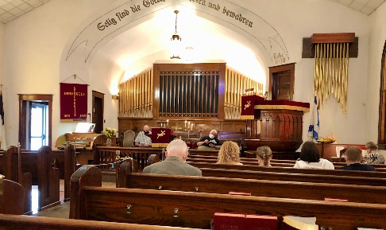

At any particular time, I enjoy thinking about what life was like in Russia for many of our ancestors. Late September and October were the days when the harvest took place.
While there were merchants, artisans, and others who manufactured items in the villages (along with the School Masters and the esteemed Pastors), the majority of the German colonists were farmers.
In the Volga region farming was established on a system that was quite different from what we think of as today’s farm. The people lived in the villages in blocklike sections that each contained 4 family homes. Included in each family’s section was their house and an area for their animals. Often that animal shelter was attached to the family home! I am sure that made for some interesting smells in the summer. They also had an area for a garden plot where they could grow vegetables and fruits for their own usage. But this is not where they farmed.
The actual farming was not done inside the village. The people would go out to their sections of land in the countryside to farm. The land itself was owned by the village and it was in turn divided up based on the number of males in each family.
This was ok at first, but eventually there was not enough land to support the number of people in the villages and daughter colonies were formed (i.e. Neu Norka or New Norka). These daughter colonies were often quite a few miles away from the original villages. Since the people didn’t actually own the land, most Volga Germans were quite poor when they left Russia. They could only bring what money they received from selling their animals and their house and its contents.
But back to farming. The people would walk or ride their ox or horse drawn carts out to the fields to harvest their crops. All the family would help with harvest. Both men and women and older children worked in the fields. Younger children would watch over even younger children back in the village. Families were fortunate if they had an old woman in the family to take care of the young children and to cook meals for the workers in the fields.

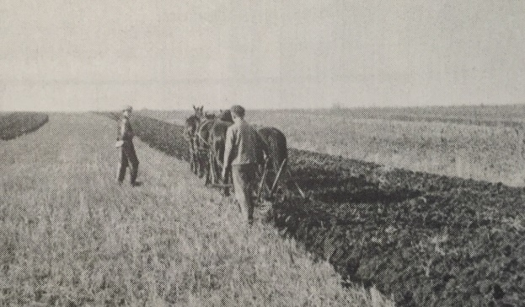

I have seen pictures of the German people standing around a boiling pot of water making “feld glace/gleece” or field dumplings. Bierocks or runzas were most likely made to be something the workers could take to the fields for their lunch.
These same people left their homes in Russia to come to the Americas for a better life. Let’s remember to be thankful for them and for the wonderful lives they built here. No matter if your family was German Russian, Swedish, Danish, Italian, Mexican, or something else, we all have much to be thankful for. And we all have much to be praying for. God bless this beautiful, wonderful land of ours!

Immanuel celebrates its 129th birthday this month. Happy Birthday Immanuel!
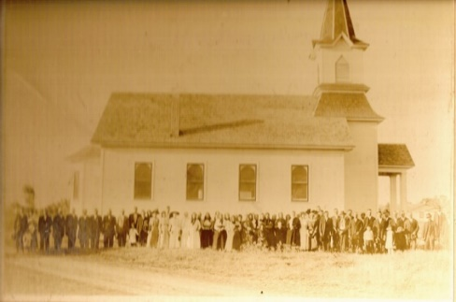
How do you begin to reflect on 129 years of God’s faithfulness? If those 13 founding members were to see Immanuel Church today would they be surprised, pleased or disappointed at how the seeds they planted have continued to bloom and prosper? I think they would be happy to see we continue to preach God’s word; we love one another, and we seek to be His light in the world around us.

Guiding Light Ladies will be notifying the members by email regarding the October “Get Together”. Watch your email for details.

Heritage Club- We have not scheduled anything due to Covid for the rest of the year. Watch the Newsletters and Bulletins for any future Heritage Club activities.

Sunday School-
Children’s Sunday School- Sunday 9:15am in the lower level of the Church.
Adult Sunday School- 9:15am in the Fellowship Hall
Bible Study:
Lamb’s Club (Ram’s welcome) Tuesday 10:00am in the Fellowship Hall. Currently is not meeting.
Adult Bible Study- Tuesday 6:00 pm in the Fellowship Hall

Prayers
Marie Green
Nancy Loos
Tim Hardt
Vangie Brehm
Esther Burback
Donna Day
Harry & MaryAnn Schneider
Kyle Kelley & Family
Becky Schenaman
Lisa Bokelman

Birthdays
1 Rhonda Wagner 16 Wilma Sundeen
4 Jaxon Brock 16 Andrew Bloskas
4 Donna Crosby 17 Terri Jensen
6 David Loos 21 Sharon Pike
6 Paul Loos 23 Stephen Loos
6 Tom Corey 27 Debbie Krantz
9 Sharon Brehm 29 Betsy Will
10 Dave Worster
12 Tammy Loos

Anniversaries
1 Matt & Jennifer Will
23 Alan & Mary Pat Loos

Immanuel Military Prayer
Lord, please hold our troops in your loving hands. Protect them as they protect us. Bless them and their families for their selfless acts they perform for us in our time of need.
Please keep Immanuel’s Military and Law Enforcement Personnel and Families in your prayers. Let me know if I left anyone out, please.
Toby Rekart-Law Enforcement Kyle Kelley-Military
Chance Huck- Military Terry Wagner-Law Enforcement
Dustin Skinner-Military

