Immanuel

Church 129

Shining God’s light for 129 Years

Immanuel Church Newsletter November 2020

Pastor Pete’s Pen

My computer keyboard and I are not “friends” at the moment. It either won’t type at all or it will go crazy and type letters I haven’t even touched.

My frustration hit a new high a couple of weeks ago when I was trying to make a final correction on our worship folder before sending it to Cyndee for printing. The keyboard would not make the correction. For ten minutes I struggled without success. My mouse worked, but the keyboard would not respond.

At the height of my frustration, the lovely Miss Vi walked into my office and asked about my problem. Thinking she might give me a little sympathy, I told her what I was experiencing. She looked at my desk top and started to laugh. What she saw, that I had not, was I was using the wrong keyboard. I was typing on our grandson’s fake computer keyboard.

Thanks to Miss Vi in just a few moments I was able to make the correction and send the worship folder on its way. Wow, when you think about it, I was trying to do the right thing but using the wrong source.

Many people live their lives in that same manner. Striving to do the right thing but doing it in their own power. Unwilling to rely on the almighty power found in the name Jesus and in the Word of God.

^{Psalm 1.1} Oh, the joys of those who do not follow the
advice of the wicked, or stand around with sinners, or join in with mockers. ² But they delight in the law of the Lord, meditating on it day and night. ³ They are like trees planted along the riverbank, bearing fruit each season. Their leaves never wither, and they prosper in all they do. Psalm 1:1 – 3 NLT

May each of the
Immanuel Saints grow in
Knowledge and Grace
of the Lord Jesus Christ
during our 130th year.

In verse 1 the psalmist informs us in whom we should not trust in our quest for happiness:
- Unrighteous people
- Those who practice sin
- Those who enjoy mocking others
The last two are practiced by the unrighteous and by some believers who do not meditate on God’s Word.

Instead the real source of joy is meditating on the Word of God whenever a person has opportunity. The psalmist gives us a picture of what meditating on the Word of God looks like in nature. We become like a tree, planted securely in the right spot, flourishing, fruitful, and, when we act in accordance to the will of God for us, we are prosperous (that is, we are successful in doing what God intended us to do).

According to TreePeople.org here are some of the 22 benefits that come from a tree (the spiritual applications are mine):
- A tree slows climate change – The joy filled person who is filled with and living the Word of God will slow the speed of culture corruption. (Romans 1:21 – 32)
- A tree provides clean air and oxygen – A Christ follower will not add to existing pollution but be an agent who promotes spiritual health and cleanliness.
- A tree marks the seasons – a spiritual healthy believer lives aware that Christ could return at any time. Therefore we warn others to repent of their sin and receive Jesus Christ as Savior while there is time.
- A tree provides a home and food for small animals – A student of God’s Word does not live selfishly. God blesses us so that we can bless others.
- A tree provides beauty – Through God’s Word and by God’s grace our attitudes and actions should give pleasantness to those whom we encounter.
- A tree gives shade and shelter – Meditating on the Word of God helps us bring calmness and give refuge to others.

My prayer for Immanuel’s 130th year is for each Immanuel saint to be like the tree described in
Psalm 1 and together we will be a beautiful forest, glorifying the Creator and helping His creation.

Celebrating Immanuel’s 129th Birthday!

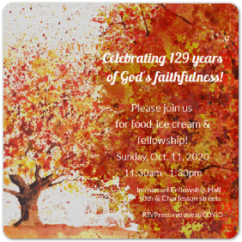

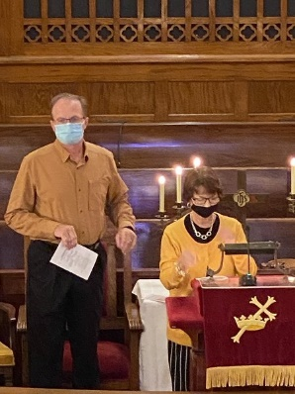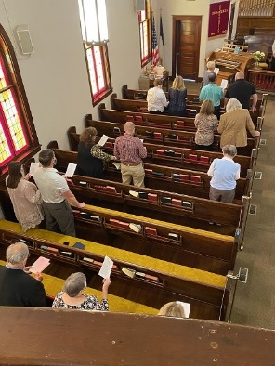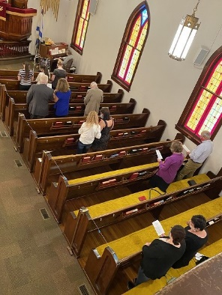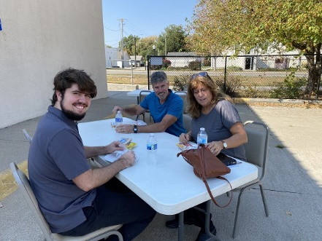

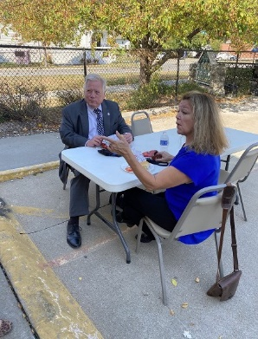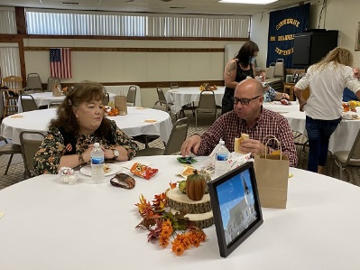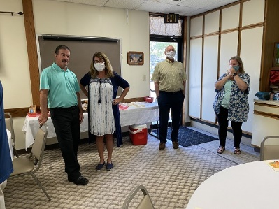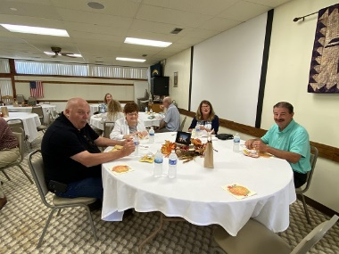

Happy Thanksgiving!
Easy Pumpkin Pie Squares- 24 servings- 9x13 pan- Preheat oven to 350 degrees
½ c butter, softened 1 (15oz) can of pumpkin
½ c brown sugar 1 (12oz) can evaporated milk
1 c all-purpose flour ½ tsp salt
½ c rolled oats 1 tsp ground cinnamon
2 eggs ½ tsp ground ginger
¾ c white sugar ¼ tsp ground cloves
In a medium bowl, cream together butter & brown sugar. Mix in flour, fold in oats, press into baking dish. Bake in preheated oven 15 minutes, until set.
In a large bowl, beat eggs with white sugar. Beat in pumpkin and evaporated milk. Mix in salt, cinnamon, ginger and cloves. Pour over baked crust.
Bake in preheated oven 20 minutes, until set. Let cool before cutting into squares.
NOTE: You can make them in a muffin pan also and I would recommend you use cupcake liners.

Guiding Light Ladies will not be meeting in November.

Heritage Club- We have not scheduled anything due to Covid for the rest of the year. Watch the Newsletters and Bulletins for any future Heritage Club activities.

Sunday School-
Children’s Sunday School- Sunday 9:15am in the lower level of the Church.
Adult Sunday School- Currently not meeting

Bible Study:
Lamb’s Club (Ram’s welcome) Tuesday 10:00am in the Fellowship Hall. Currently is not meeting.
Adult Bible Study- Tuesday 6:15pm in the Fellowship Hall

Prayers
Marie Green
Nancy Loos
Tim Hardt
Vangie Brehm
Esther Burback
Donna Day
Harry & MaryAnn Schneider
Kyle Kelley & Family
Becky Schenaman
Margaret Jones

Birthday
5 Rob Parks 11 Kevin Anderson
7 Kristi Horeis 12 Bob Cypher
8 Becky Schenaman 13 Shari Cypher
8 Luke Thaller 28 Susan Corey

Anniversaries
6 Hank & Sarah Loos

Immanuel Military Prayer
Lord, please hold our troops in your loving hands. Protect them as they protect us. Bless them and their families for their selfless acts they perform for us in our time of need.
Please keep Immanuel’s Military and Law Enforcement Personnel and Families in your prayers. Let me know if I left anyone out, please.
Toby Rekart-Law Enforcement Kyle Kelley-Military
Chance Huck- Military Terry Wagner-Law Enforcement
Dustin Skinner-Military

