Immanuel

Church 129

Shining God’s light for 129 Years

**Immanuel Church Newsletter February 2021**

**Pastor Pete’s Pen**

**You’ve Got to Experience . . .**

When a person is fortunate to enjoy the blessing of having more years behind him than are in front of him, there are a number of things that roll through your memory. I believe it is healthy to remember how God blessed and used you in times past, even in those occasions when you were just trying to earn money. On those occasions there was nothing spiritual motivating your decision, but His faithfulness and favor then provide spiritual resource for today.

I sold cookware in the late 60’s. Door-to-door, by reference and at county fairs and the Nebraska State Fair. I loved “hawking my wares at the fair.” I should have copyrighted my presentations because I hear some of my glib remarks on those TV infomercials. Just a hint, if I could hook a gentleman’s interest in my product, and then convince his wife that it could deliver everything and more than I promised – the cost of the cookware was never a problem. In fact the man would upgrade the basic set to the premium.

The best way we discovered to sell our product was to offer a follow up dinner for a couple who had recently purchased a set of cookware. I promised to purchase and prepare all the food, including appetizer, salad, main course with three vegetables and dessert, and to clean all the cooking utensils and the kitchen IF they would invite four or five couples for dinner. I promised there would be no selling that evening and the appetizer course would be provided through a 15 minute demonstration of nutritional food preparation. However, each couple invited had to promise and schedule a 15 minute, follow up appointment for the next day, when the three of us would meet and discuss their experience.

You see, I was not selling cookware. I was selling nutrition, health and low-cost tasty food. But my prospect had to experience how those three could coexist.

My four critical success factors were:

1. The nutritional demonstration – truth delivered within a fun atmosphere.
2. A tender, fall-off-the bone, seven-bone roast. As I remember the cost was around 59 cents a lb.
3. Cabbage – men love sweet and tender cabbage. And women like it too, especially when it is prepared in a manner that does not produce overnight negative sensations.
4. The follow up – no longer than 15 minutes. You never have to sell to someone who wants to buy.

I met a lot of great people in the two years I sold Salad Master. I concentrated on rural areas, people who appreciated tasty food and value. And we had a lot of fun. My purpose was to accumulate enough money to purchase the engagement ring my wife is still wearing. And we still use my cookware, still has a life-time guarantee and looks almost new after 55 years of use.

So Pastor Pete, what’s your point?

***Oh, taste and see that the Lord is good!***

***Blessed is the man who takes refuge in him! Ps. 34:8***

If you are a believer in Jesus Christ, your citizenship is in heaven. On earth you are an ambassador of the Gospel, and you are one of God’s critical success factors. No, we don’t sell the Gospel. But the Lord allows others to experience it through how you and I live out the Gospel, especially in times of testing.

Whatever your test may be, His lifetime guarantee is that God’s blessing will rest upon you if He is your refuge. A faith that is tested is a faith that can be trusted.

***Walk in wisdom toward outsiders, making the best use of the time. Let your speech always be gracious, seasoned with salt, so that you may know how you ought to answer each person. Colossians 4:5 & 6***

Would you please pass the cabbage?

Dear Immanuel Church Friends, Warm greetings to you all!

One of the many things that I enjoy at Immanuel is starting the year off every January with Prayer Week. This tradition has been maintained for as long as I can remember, and this year was no different. Oh sure, due to Covid we held Prayer Week in our church building proper and not the Fellowship Hall. But this is where it was held when I was a little girl. The old women used to all sit on the east side of the church and all the old men on the west. We no longer do that but we still have heartfelt prayers and excellent speakers during this week.

Each day of Prayer Week we were blessed by speakers representing a different group from the church. (Sun - Elders, Mon – Church Board, Tues – Bible Studies, Wed – Sunday School and Thurs – Guilding Light Ladies. It was truly a blessing!

Jeremiah 29 :12 “Then you will call upon Me and come and pray to Me, and I will listen to you.”

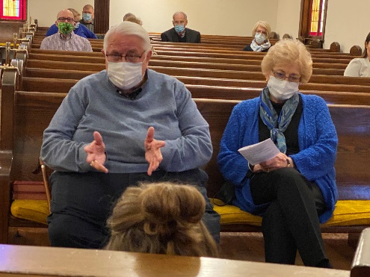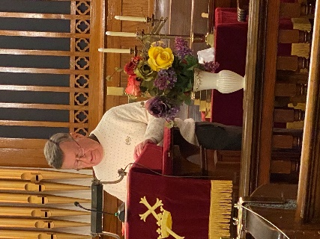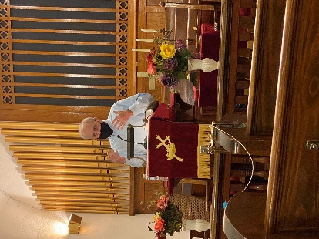

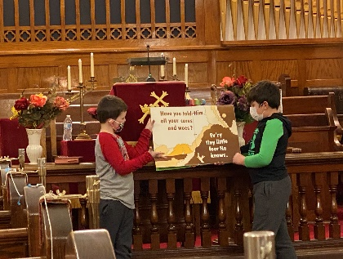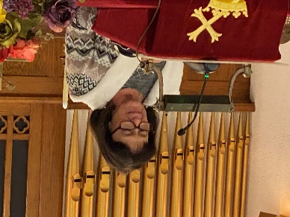 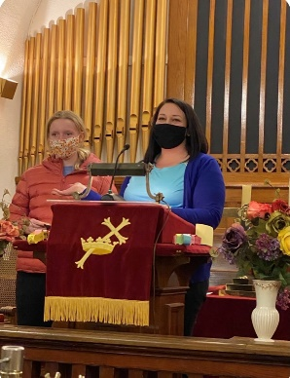

Due to Valentine’s Day, we often think of the colors red/pink and sweet things to eat when we think of the month of February. I am including a picture of a beloved German Russian treat – Eben Gleece (Strawberry Dumplings) and a link to a recipe for these scrumptious delights.

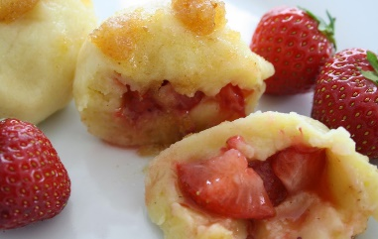

In German the word for strawberry is erdebeere and dumplings are kloss. So, when you have a Volga German dialect Erdeberren Kloss becomes a bit slurred and sounds like eben gleece. But no matter how you pronounce them they are a special treat (noodlelike dough with strawberry filling and buttery creamy sauce).  https://www.norkarussia.info/strawberry-dumplings.html

If you would like to learn more about traditions in the German villages in Russia go to [www.norkarussia.info](http://www.norkarussia.info). There you will learn so many wonderful facts about the German Russian villages and traditions.

Thank you Lord for all your blessings, and “Mach’s Gut” (Take Care) dear Friends.

Sherry Pawelko

**Guiding Light Ladies**- Just wanted to let everyone know that we are **not** planning to have a February GLL Meeting.   We will continue to keep you posted, so please check your email. If you know someone that is not listed on our email list, please update them.

Also, If you did not read in the newsletter, we are looking for someone to take on decorating the church.   If you are interested, please contact Susan, Joyce or Mary Pat.

**Heritage Club** is still on hold due to Covid. Stay safe and healthy.

**Sunday School-**

**Children’s Sunday School**- 9:15am lower level of the Church

**Adult Sunday School-** **There is no Adult Sunday School until further notice.**

**Bible Study:**

**Lamb’s Club** (Ram’s welcome) Tuesday 10:00am in the Fellowship Hall. **Currently is not meeting.**

**Adult Bible Study**- Tuesday 6:00 pm in the Fellowship Hall. If you would like to attend via Zoom, you can contact Joe Jensen for details on how to do that.

**Prayers Birthdays Anniversaries**

Marie Green 3 Annie Parks 22 John Huck

Virginia Rekart 5 James Brock 25 Virginia Rekart

Tim Hardt 6 Elizabeth Siefker 26 Marcus Rekart

Vangie Brehm 13 Molly Grasmick 26 Carol Brown

Esther Burback 17 Barry Siedell

Donna Day 17 Rev. Dennis Swenson

Harry & MaryAnn Schneider

Becky Schenaman

**Immanuel Military Prayer**

Lord, please hold our troops in your loving hands. Protect them as they protect us. Bless them and their families for their selfless acts they perform for us in our time of need.

Please keep Immanuel’s Military and Law Enforcement Personnel and Families in your prayers. Let me know if I left anyone out, please.

Toby Rekart-Law Enforcement Kyle Kelley-Military Dustin Skinner-Military

Chance Huck- Military Terry Wagner-Law Enforcement